LAB ASSIGNMENT – 14.1
NAME: SHAIK AFRID
ROLL.NO: 2503A52385
Task 1 – Portfolio Website Design
You are building a personal portfolio website to showcase your work.
Requirements:
Create sections for About Me, Projects, and Contact.
Use AI to:
o Suggest color palettes and typography.
o Create a responsive layout with Grid/Flexbox.
o Add smooth scrolling navigation.
PROMPT:
Create a responsive personal portfolio website using HTML, CSS and JavaScript.
Include About Me, Projects and Contact sections.
Use a professional color palette, modern typography, CSS Grid/Flexbox and smooth scrolling navigation.
Make the website responsive for mobile and desktop.
CODE:
<!DOCTYPE html>
<html>
<head>
<title>Shaik Afrid | Portfolio</title>
<style>
* {
margin: 0;
padding: 0;
box-sizing: border-box;
}
html {
scroll-behavior: smooth;
}
body {
font-family: 'Segoe UI', Tahoma, Geneva, Verdana, sans-serif;
background: #f8fafc;
color: #1e293b;
}
nav {
background: #0f172a;
padding: 18px 8%;
display: flex;
justify-content: space-between;
align-items: center;
flex-wrap: wrap;
box-shadow: 0 2px 10px rgba(0,0,0,0.1);
}
nav h2 {
color: #38bdf8;
font-size: 22px;
font-weight: 700;
}
nav a {
color: #f1f5f9;
text-decoration: none;
margin-left: 24px;
font-weight: 500;
transition: color 0.2s;
}
nav a:hover {
color: #38bdf8;
}
section {
padding: 55px 10%;
text-align: center;
}
#about {
background: #e2e8f0;
}
#about h1 {
color: #0f172a;
font-size: 30px;
margin-bottom: 15px;
}
#about p {
font-size: 16px;
max-width: 750px;
margin: 0 auto;
line-height: 1.6;
color: #334155;
}
#projects {
background: #ffffff;
}
#projects h1 {
color: #0f172a;
font-size: 30px;
margin-bottom: 10px;
}
.project-container {
display: grid;
grid-template-columns: repeat(auto-fit, minmax(260px, 1fr));
gap: 25px;
margin-top: 30px;
}
.project {
background: #f1f5f9;
padding: 28px 20px;
border-radius: 12px;
border: 1px solid #cbd5e1;
box-shadow: 0 4px 6px -1px rgba(0,0,0,0.05);
transition: transform 0.3s ease, box-shadow 0.3s ease;
}
.project:hover {
transform: translateY(-6px);
box-shadow: 0 10px 15px -3px rgba(0,0,0,0.1);
border-color: #38bdf8;
}
.project h3 {
color: #0369a1;
font-size: 20px;
margin-bottom: 10px;
}
.project p {
color: #475569;
font-size: 14px;
line-height: 1.5;
}
#contact {
background: #e2e8f0;
}
#contact h1 {
color: #0f172a;
font-size: 30px;
margin-bottom: 15px;
}
#contact p {
font-size: 16px;
color: #334155;
margin-bottom: 20px;
}
button {
background: #0284c7;
color: white;
padding: 12px 30px;
border: none;
border-radius: 6px;
font-size: 15px;
font-weight: 600;
cursor: pointer;
transition: background 0.2s;
}
button:hover {
background: #0369a1;
}
@media(max-width: 600px) {
nav {
flex-direction: column;
gap: 12px;
}
nav a {
margin: 0 10px;
}
section {
padding: 40px 5%;
}
}
</style>
</head>
<body>
<nav>
<h2>Shaik Afrid | Portfolio</h2>
<div>
<a href="#about">About</a>
<a href="#projects">Projects</a>
<a href="#contact">Contact</a>
</div>
</nav>
<section id="about">
<h1>About Me</h1>
<p>Hello! I am Shaik Afrid, a Computer Science & Engineering student specializing in Artificial Intelligence and Full-Stack Development. I love creating performant web applications and data-driven intelligent systems.</p>
</section>
<section id="projects">
<h1>Featured Projects</h1>
<div class="project-container">
<div class="project">
<h3>CodeSight Assistant</h3>
<p>An automated AI-powered code analysis and documentation generation platform.</p>
</div>
<div class="project">
<h3>Cloud Vault Hub</h3>
<p>A distributed secure cloud storage and synchronized backup utility.</p>
</div>
<div class="project">
<h3>Student Analytics Portal</h3>
<p>A responsive academic performance and course tracking management system.</p>
</div>
</div>
</section>
<section id="contact">
<h1>Contact Me</h1>
<p>Email: afrid.sk@gmail.com</p>
<button onclick="contactMessage()">Get in Touch</button>
</section>
<script>
function contactMessage() {
alert("Thank you for reaching out to Shaik Afrid! I will get back to you soon.");
}
</script>
</body>
</html>
OUTPUT:
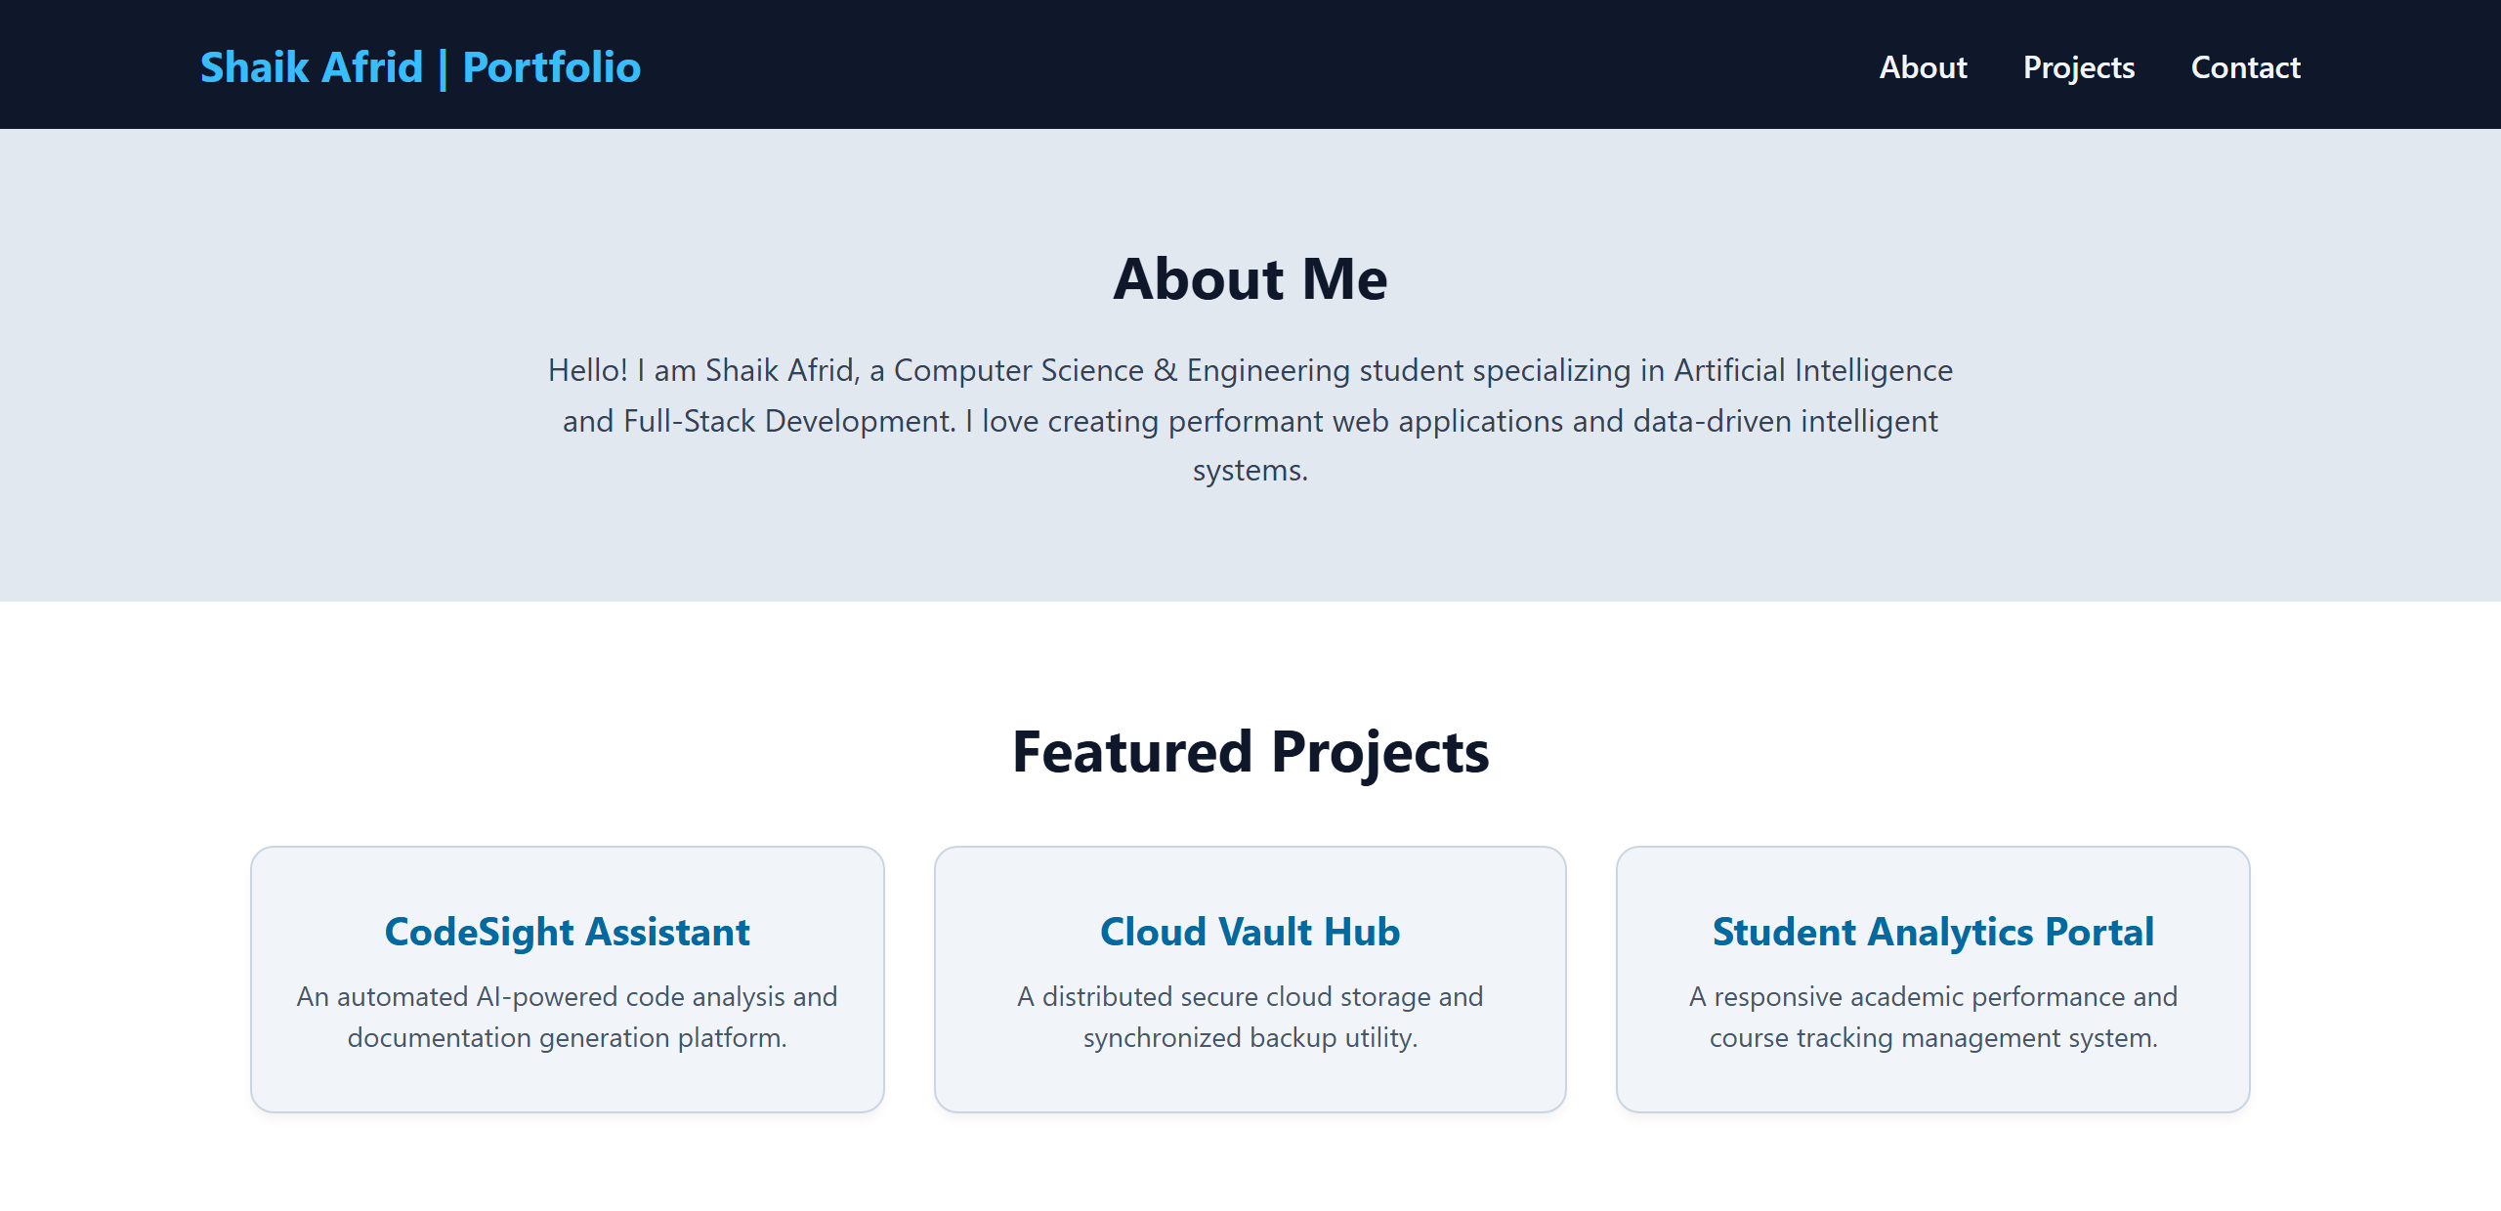
Task 2 – Online Store Product Page
Design a product display page for an online store.
Requirements:
Display product image, title, price, and "Add to Cart" button.
Use AI to:
o Style with BEM methodology.
o Make layout responsive.
o Add hover effects and "Add to Cart" alert.
PROMPT:
Create an online store product page using HTML, CSS and JavaScript.
Display a product image, title, price and Add to Cart button.
Use BEM naming methodology for CSS classes.
Make the page responsive and add hover effects.
When the Add to Cart button is clicked, display an alert.
CODE:
<!DOCTYPE html>
<html>
<head>
<title>TechMart | Product Details</title>
<style>
* {
box-sizing: border-box;
margin: 0;
padding: 0;
}
body {
font-family: 'Segoe UI', Tahoma, Geneva, Verdana, sans-serif;
background: #f1f5f9;
text-align: center;
padding: 25px;
}
.store-header {
margin-bottom: 25px;
}
.store-header h1 {
color: #0f172a;
font-size: 28px;
font-weight: 700;
}
.product-card {
background: #ffffff;
max-width: 360px;
margin: 0 auto;
padding: 24px;
border-radius: 14px;
box-shadow: 0 10px 25px -5px rgba(0,0,0,0.08);
border: 1px solid #e2e8f0;
transition: transform 0.3s ease, box-shadow 0.3s ease;
}
.product-card:hover {
transform: translateY(-5px);
box-shadow: 0 16px 30px -4px rgba(0,0,0,0.12);
}
.product-card__image-wrapper {
background: #f8fafc;
border-radius: 10px;
padding: 20px;
display: flex;
align-items: center;
justify-content: center;
height: 200px;
border: 1px dashed #cbd5e1;
}
.product-card__svg {
width: 140px;
height: 140px;
}
.product-card__badge {
display: inline-block;
background: #dbeafe;
color: #1d4ed8;
font-size: 11px;
font-weight: 700;
padding: 4px 10px;
border-radius: 20px;
margin-top: 15px;
text-transform: uppercase;
letter-spacing: 0.5px;
}
.product-card__title {
color: #0f172a;
font-size: 20px;
margin: 12px 0 6px 0;
font-weight: 600;
}
.product-card__desc {
color: #64748b;
font-size: 13px;
margin-bottom: 14px;
line-height: 1.4;
}
.product-card__price {
color: #059669;
font-size: 26px;
font-weight: 700;
margin-bottom: 16px;
}
.product-card__button {
width: 100%;
background: #2563eb;
color: #ffffff;
padding: 13px 20px;
border: none;
border-radius: 8px;
font-size: 15px;
font-weight: 600;
cursor: pointer;
transition: background 0.2s, transform 0.2s;
}
.product-card__button:hover {
background: #1d4ed8;
transform: scale(1.02);
}
@media(max-width: 500px) {
.product-card {
width: 100%;
}
}
</style>
</head>
<body>
<div class="store-header">
<h1>TechMart Gadget Store</h1>
</div>
<div class="product-card">
<div class="product-card__image-wrapper">
<svg class="product-card__svg" viewBox="0 0 24 24" fill="none" stroke="#2563eb" stroke-width="1.5" stroke-linecap="round" stroke-linejoin="round">
<rect x="5" y="2" width="14" height="20" rx="7" ry="7"></rect>
<circle cx="12" cy="12" r="4"></circle>
<path d="M12 9v3l2 2"></path>
</svg>
</div>
<span class="product-card__badge">In Stock • Best Seller</span>
<h2 class="product-card__title">Smart Fitness Watch Pro</h2>
<p class="product-card__desc">AMOLED display, 24/7 heart rate monitoring, GPS tracking & 10-day battery life.</p>
<p class="product-card__price">₹2,499</p>
<button class="product-card__button" onclick="addToCart()">Add to Cart</button>
</div>
<script>
function addToCart() {
alert("Success! Smart Fitness Watch Pro has been added to your shopping cart.");
}
</script>
</body>
</html>
OUTPUT:
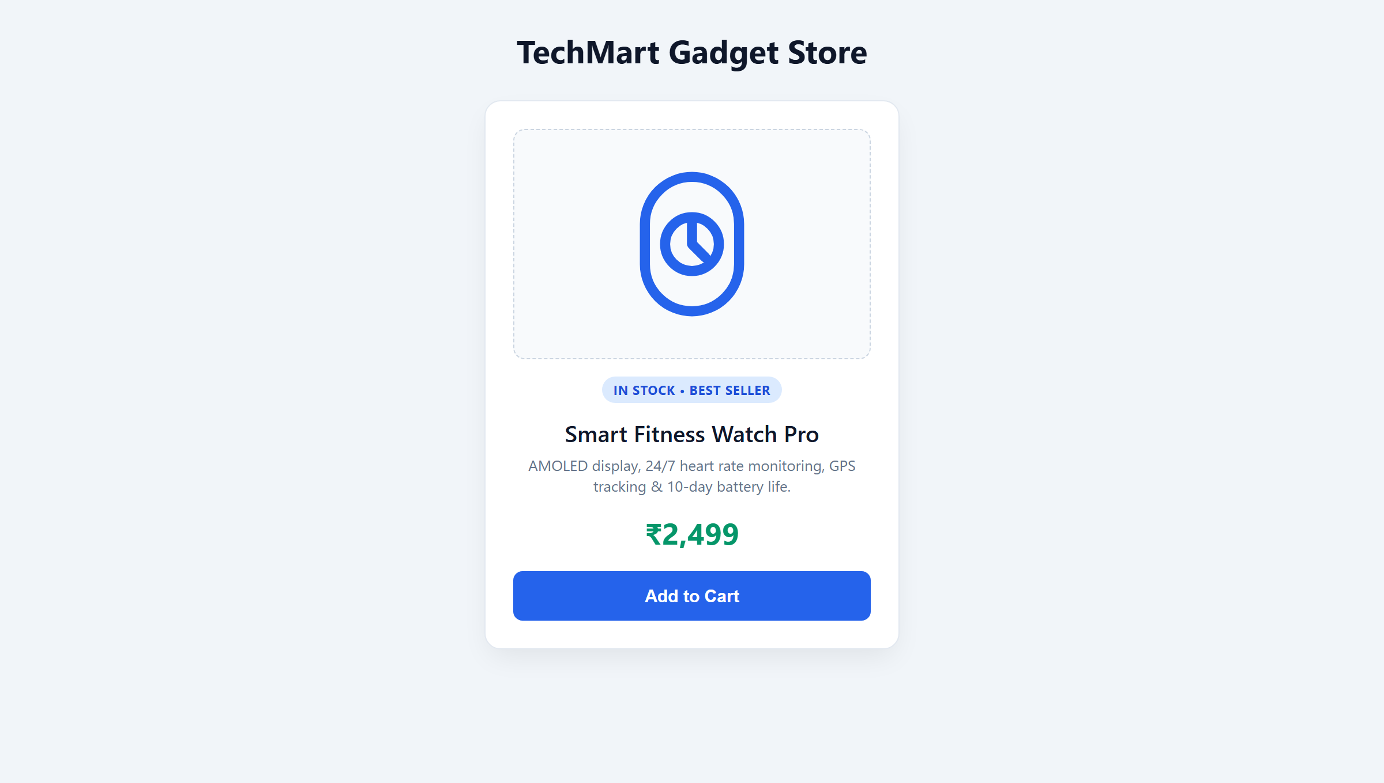
Task 3 – Event Registration Form
Build an event registration form for a conference.
Requirements:
Collect name, email, phone number, and session selection.
Use AI to:
o Add form validation with JavaScript.
o Make the form accessible with labels and ARIA.
o Style with a professional look.
PROMPT:
Create a conference event registration form using HTML, CSS and JavaScript.
Collect name, email, phone number and session selection.
Add JavaScript form validation.
Use proper labels and ARIA attributes.
Create a professional and responsive design.
Display a success message after valid submission.
CODE:
<!DOCTYPE html>
<html>
<head>
<title>Developer Summit | Event Registration</title>
<style>
* {
box-sizing: border-box;
margin: 0;
padding: 0;
}
body {
font-family: 'Segoe UI', Tahoma, Geneva, Verdana, sans-serif;
background: #e0f2fe;
padding: 30px 15px;
display: flex;
align-items: center;
justify-content: center;
min-height: 100vh;
}
.form-container {
background: #ffffff;
width: 100%;
max-width: 480px;
padding: 32px;
border-radius: 14px;
box-shadow: 0 10px 25px -5px rgba(2, 132, 199, 0.15);
border: 1px solid #bae6fd;
}
h1 {
text-align: center;
color: #0369a1;
font-size: 24px;
font-weight: 700;
margin-bottom: 8px;
}
.subtitle {
text-align: center;
color: #64748b;
font-size: 13px;
margin-bottom: 22px;
}
label {
display: block;
margin-top: 14px;
color: #1e293b;
font-weight: 600;
font-size: 13px;
}
input, select {
width: 100%;
padding: 11px 14px;
margin-top: 6px;
border: 1px solid #cbd5e1;
border-radius: 6px;
font-size: 14px;
background: #f8fafc;
color: #0f172a;
outline: none;
transition: border-color 0.2s, box-shadow 0.2s;
}
input:focus, select:focus {
border-color: #0284c7;
background: #ffffff;
box-shadow: 0 0 0 3px rgba(2, 132, 199, 0.15);
}
button {
width: 100%;
background: #0284c7;
color: #ffffff;
padding: 13px;
border: none;
margin-top: 24px;
cursor: pointer;
border-radius: 6px;
font-size: 15px;
font-weight: 600;
transition: background 0.2s;
}
button:hover {
background: #0369a1;
}
#message {
text-align: center;
color: #15803d;
font-size: 14px;
font-weight: 600;
margin-top: 18px;
padding: 10px;
background: #f0fdf4;
border-radius: 6px;
border: 1px solid #bbf7d0;
display: none;
}
</style>
</head>
<body>
<div class="form-container">
<h1>Global AI & Tech Summit 2026</h1>
<p class="subtitle">Complete the form below to secure your event pass</p>
<form onsubmit="register(event)">
<label for="name">Full Name:</label>
<input type="text" id="name" value="Shaik Afrid" required aria-required="true">

<label for="email">Email Address:</label>
<input type="email" id="email" value="afrid.sk@gmail.com" required aria-required="true">

<label for="phone">Phone Number:</label>
<input type="tel" id="phone" value="9876543210" pattern="[0-9]{10}" title="Enter a 10-digit phone number" required>

<label for="session">Select Focus Track:</label>
<select id="session" required>
<option value="AI & Machine Learning" selected>Artificial Intelligence & ML</option>
<option value="Cloud Architecture">Cloud Architecture & DevOps</option>
<option value="Cybersecurity">Cybersecurity & Data Privacy</option>
<option value="Full-Stack Web">Full-Stack Modern Web Engineering</option>
</select>

<button type="submit">Complete Registration</button>
</form>
<p id="message" role="status" aria-live="polite"></p>
</div>
<script>
function register(event) {
event.preventDefault();
let name = document.getElementById("name").value;
let session = document.getElementById("session").value;
let msg = document.getElementById("message");
msg.style.display = "block";
msg.innerHTML = "Registration Confirmed! Welcome, " + name + ". Track: " + session;
}
</script>
</body>
</html>
OUTPUT:
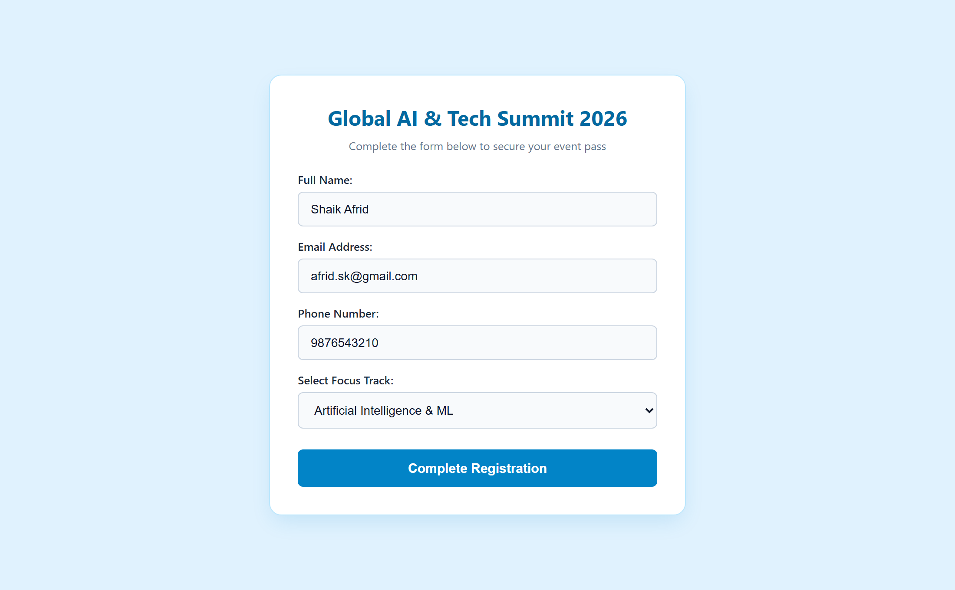
Task 4 – Resume Website
Build a one-page online resume.
Requirements:
Sections: Profile Summary, Skills, Education, Experience.
Use AI to:
o Propose professional typography styles.
o Align sections using CSS Grid.
o Add smooth scroll navigation between sections.
PROMPT:
Create a one-page resume website using HTML, CSS and JavaScript.
Include Profile Summary, Skills, Education and Experience.
Use professional typography and CSS Grid for alignment.
Add smooth scrolling navigation.
Make the website responsive.
CODE:
<!DOCTYPE html>
<html>
<head>
<title>Shaik Afrid | Curriculum Vitae</title>
<style>
* {
box-sizing: border-box;
margin: 0;
padding: 0;
}
html {
scroll-behavior: smooth;
}
body {
font-family: 'Segoe UI', Tahoma, Geneva, Verdana, sans-serif;
background: #f8fafc;
color: #1e293b;
}
header {
background: #0f172a;
color: white;
text-align: center;
padding: 32px 20px 20px 20px;
}
header h1 {
font-size: 28px;
color: #f8fafc;
margin-bottom: 6px;
}
header p {
color: #94a3b8;
font-size: 15px;
}
nav {
background: #1e293b;
padding: 14px;
text-align: center;
border-bottom: 1px solid #334155;
}
nav a {
color: #e2e8f0;
text-decoration: none;
margin: 0 16px;
font-size: 14px;
font-weight: 500;
transition: color 0.2s;
}
nav a:hover {
color: #38bdf8;
}
.container {
display: grid;
grid-template-columns: 1fr 1fr;
gap: 22px;
padding: 30px 8%;
max-width: 1200px;
margin: 0 auto;
}
.box {
background: #ffffff;
padding: 26px;
border-radius: 12px;
box-shadow: 0 4px 6px -1px rgba(0,0,0,0.06);
border: 1px solid #e2e8f0;
transition: transform 0.2s ease;
}
.box:hover {
transform: translateY(-3px);
}
h2 {
color: #0284c7;
font-size: 19px;
margin-bottom: 12px;
border-bottom: 2px solid #e0f2fe;
padding-bottom: 6px;
}
p, li {
color: #475569;
font-size: 14px;
line-height: 1.6;
}
ul {
list-style: none;
padding-left: 0;
}
ul li {
position: relative;
padding-left: 20px;
margin-bottom: 6px;
}
ul li::before {
content: "•";
color: #0284c7;
font-size: 18px;
position: absolute;
left: 4px;
top: -2px;
}
@media(max-width: 700px) {
.container {
grid-template-columns: 1fr;
}
nav a {
display: inline-block;
margin: 6px 10px;
}
}
</style>
</head>
<body>
<header>
<h1>Shaik Afrid</h1>
<p>B.Tech – Computer Science & Engineering (AI & ML)</p>
</header>
<nav>
<a href="#profile">Profile Summary</a>
<a href="#skills">Technical Skills</a>
<a href="#education">Education</a>
<a href="#experience">Experience & Projects</a>
</nav>
<div class="container">
<section class="box" id="profile">
<h2>Profile Summary</h2>
<p>Dedicated Computer Science undergraduate with hands-on proficiency in Artificial Intelligence, Machine Learning, and Full-Stack Web Development. Proven ability to architect reliable software systems, write clean code, and design user-centric digital products.</p>
</section>
<section class="box" id="skills">
<h2>Technical Skills</h2>
<ul>
<li><strong>Languages:</strong> Python, JavaScript, C++, SQL</li>
<li><strong>Web Development:</strong> HTML5, CSS3, Flexbox/Grid, Node.js</li>
<li><strong>AI & ML:</strong> Scikit-Learn, TensorFlow, Data Analytics</li>
<li><strong>Tools & Platforms:</strong> Git, MySQL Workbench, Docker, Linux</li>
</ul>
</section>
<section class="box" id="education">
<h2>Education</h2>
<p><strong>B.Tech in Computer Science and Engineering</strong></p>
<p>Specialization: Artificial Intelligence & Machine Learning</p>
<p>SR University | Roll No: 2503A52385</p>
</section>
<section class="box" id="experience">
<h2>Experience & Projects</h2>
<p><strong>AI & Web Development Intern:</strong> Engineered predictive models and interactive web dashboards.</p>
<p><strong>Hackathon Finalist:</strong> Built an automated code analysis and review utility in collaborative sprints.</p>
</section>
</div>
</body>
</html>
OUTPUT:
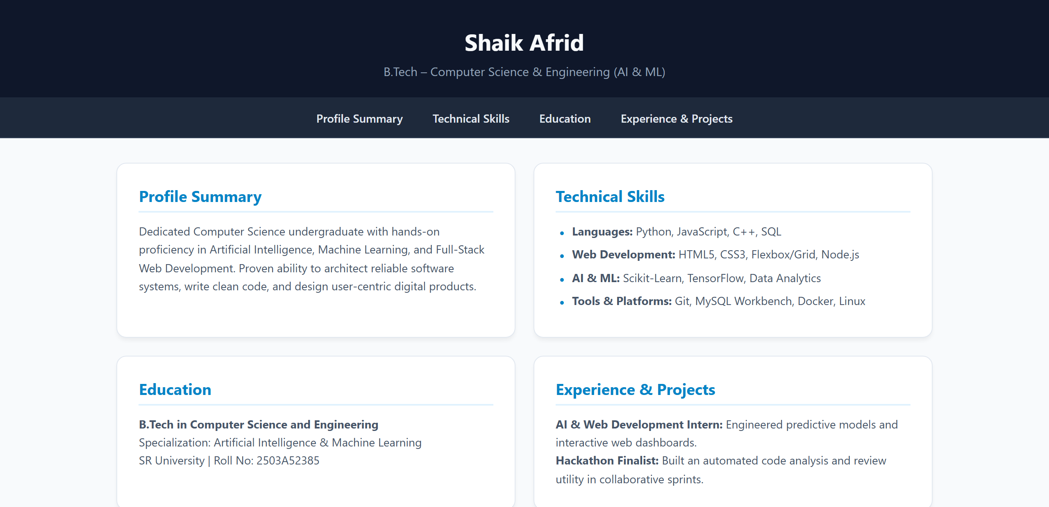
Task 5 – Restaurant Menu Page
Design a digital menu page for a restaurant.
Requirements:
Display menu items with name, description, and price.
Use AI to:
o Suggest a food-friendly color palette.
o Design a responsive card-based layout.
o Add hover effects on menu items.
PROMPT:
Create a restaurant menu webpage using HTML and CSS.
Display food items with names, descriptions and prices.
Use a food-friendly color palette such as orange, cream and brown.
Create a responsive card-based layout using CSS Grid.
Add hover effects to menu cards.
CODE:
<!DOCTYPE html>
<html>
<head>
<title>The Spice Pavilion | Digital Menu</title>
<style>
* {
box-sizing: border-box;
margin: 0;
padding: 0;
}
body {
font-family: 'Segoe UI', Tahoma, Geneva, Verdana, sans-serif;
background: #fffbeb;
color: #451a03;
padding: 30px 20px;
}
header {
text-align: center;
margin-bottom: 30px;
}
header h1 {
color: #9a3412;
font-size: 32px;
font-weight: 700;
margin-bottom: 8px;
}
header p {
color: #b45309;
font-size: 15px;
}
.menu-container {
display: grid;
grid-template-columns: repeat(auto-fit, minmax(280px, 1fr));
gap: 24px;
max-width: 1100px;
margin: 0 auto;
}
.menu-card {
background: #ffffff;
padding: 24px;
border-radius: 14px;
border: 1px solid #fde68a;
box-shadow: 0 4px 6px -1px rgba(180, 83, 9, 0.08);
text-align: center;
transition: transform 0.3s ease, box-shadow 0.3s ease;
}
.menu-card:hover {
transform: translateY(-6px);
box-shadow: 0 12px 20px -3px rgba(180, 83, 9, 0.16);
border-color: #f59e0b;
}
.menu-card h2 {
color: #c2410c;
font-size: 20px;
margin-bottom: 8px;
}
.menu-card p {
color: #78350f;
font-size: 13.5px;
line-height: 1.5;
margin-bottom: 14px;
}
.price {
color: #15803d;
font-size: 22px;
font-weight: 700;
}
footer {
text-align: center;
color: #92400e;
margin-top: 45px;
font-size: 14px;
}
</style>
</head>
<body>
<header>
<h1>Welcome to The Spice Pavilion</h1>
<p>Artisan Culinary Delights Prepared with Fresh Ingredients</p>
</header>
<div class="menu-container">
<div class="menu-card">
<h2>Paneer Tikka Platter</h2>
<p>Tandoor-charred cottage cheese cubes infused with aromatic spices and herbs.</p>
<p class="price">₹280</p>
</div>
<div class="menu-card">
<h2>Artisan Sourdough Pizza</h2>
<p>Hand-stretched pizza topped with sun-dried tomatoes, mozzarella, and fresh basil.</p>
<p class="price">₹340</p>
</div>
<div class="menu-card">
<h2>Hyderabadi Dum Biryani</h2>
<p>Slow-cooked fragrant basmati rice layered with seasoned spices and saffron.</p>
<p class="price">₹320</p>
</div>
<div class="menu-card">
<h2>Truffle Mushroom Pasta</h2>
<p>Fettuccine tossed in a velvety wild mushroom and aged parmesan cream reduction.</p>
<p class="price">₹290</p>
</div>
<div class="menu-card">
<h2>Classic Gourmet Burger</h2>
<p>Grilled veggie patty with melted cheddar, caramelized onions, and crisp fries.</p>
<p class="price">₹190</p>
</div>
<div class="menu-card">
<h2>Belgian Chocolate Lava</h2>
<p>Warm decadent molten chocolate dessert served with rich Madagascar vanilla gelato.</p>
<p class="price">₹160</p>
</div>
</div>
<footer>
<p>Thank you for dining at The Spice Pavilion! We look forward to serving you again.</p>
</footer>
</body>
</html>
OUTPUT:


